DATA FLOW DIAGRAM

- What is Data Flow Diagram (DFD) ?
A Data Flow Diagram (DFD) is a graphical representation used in software engineering to illustrate how data moves through a system. It shows the flow of information between external entities, processes, data stores, and data outputs within the system. A DFD focuses only on the movement and transformation of data, not on program logic or control flow, and is mainly used during system analysis and design to clearly understand and document system requirements.

- Explain all components of DFD ?

A DFD consists of four components: Process (transforms data), Data Flow (shows movement of data), Data Store (stores data), and External Entity (interacts with the system from outside). Together, these components represent how data moves and is processed within a system.

- Process :


A Process transforms input data into output data. It represents an activity or function performed by the system.
Examples: Validate Login, Calculate Salary, Issue Book.
- Symbol: Circle (Yourdon) or Rounded Rectangle (Gane-Sarson)
- Must have at least one input and one output
- Should be named using a verb + noun (e.g., “Process Order”)
If it has no output, it’s incomplete. If it has no input, it’s suspicious.

- Data Flow :

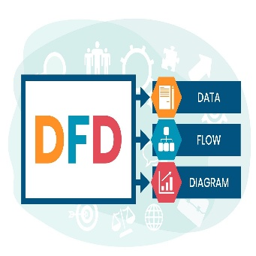
Data Flow shows movement of data between components.
Examples: Login Details, Payment Info, Student Record.
- Symbol: Arrow
- Must be labeled clearly
- Represents data, not control signals
If there’s no arrow, there’s no communication.

- Data Store :


A Data Store is where data is stored for later use.
Examples: Database, Student File, Inventory Record.
- Symbol: Two parallel horizontal lines
- Represents stored data, not processing
If data is stored permanently or temporarily, it must appear here.

- External Entity :

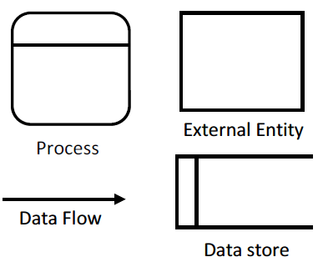

An External Entity is outside the system but interacts with it.
Examples: Student, Admin, Bank, Customer.
- Symbol: Rectangle
- Acts as source or destination of data
- Does not perform internal processing
If it’s outside system boundary, it must be shown as an external entity.

